MEGA ESOPHAGUS
THERE IS

HOPE

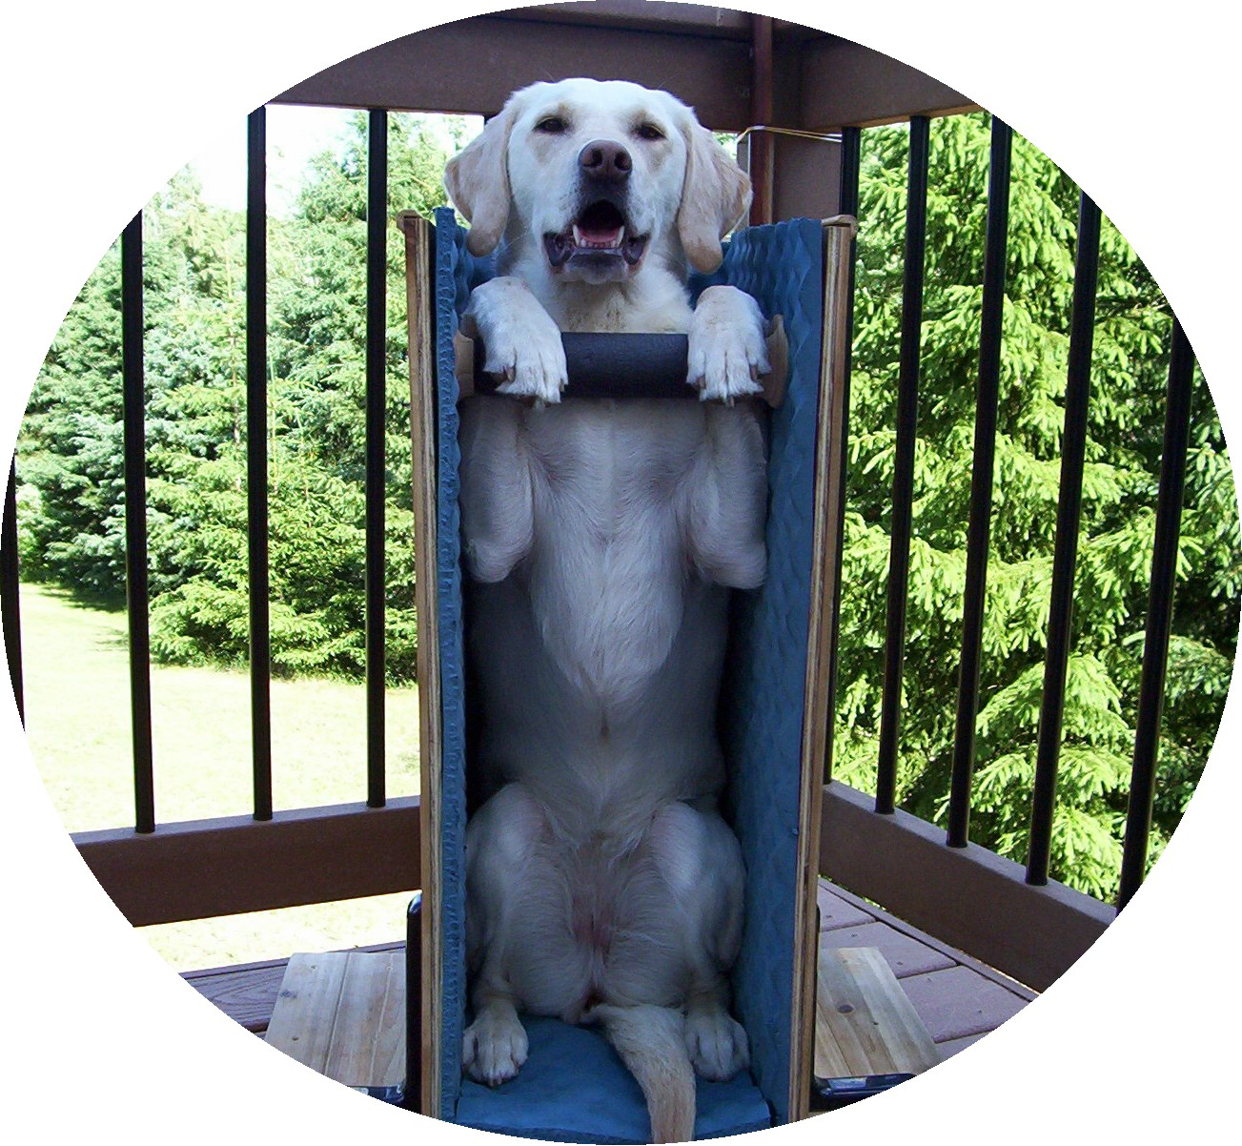

PIPER IS THRIVING WITH MEGA E (DIAGNOSED FEB. ’05)
AND IBD* (DIAGNOSED JULY ‘03)!

Mega esophagus:
What does this mean for my dog?
You have just been told your dog has mega esophagus (which you have never heard of), and you are probably feeling overwhelmed and scared. Your veterinarian explained what mega esophagus is, but where to go from here and how to help your dog maintain a good quality of life seems uncertain. Be assured that mega esophagus is not a death sentence and that your dog can lead a normal life with a few adaptations. Many others have been in the same place you are now. In fact there is a group of dog owners dealing with the same condition in their dogs and its members are available to assist you online. This group has knowledge about and experience with the follow-up care/daily management of dogs with mega esophagus. The purpose of this brochure is to share with you the valuable information that our group has learned through collective experience, helping you to provide the best daily care for your dog with mega esophagus.

We cannot stress enough the importance of partnering with your veterinarian and always discussing any changes to your dog’s care with him/her. After all, our veterinarians have medical knowledge that we do not and are familiar with our individual dogs and their unique needs. Below you will find answers to some of your initial questions about mega esophagus, and basic management recommendations from the group. We also encourage you to join the group where you can receive more individualized support and suggestions. By sharing what we have all learned through experience with our dogs, we hope to spread awareness and give peace of mind and hope to those who have just been told, “your dog has mega esophagus.”

What is Mega esophagus in simplified terms?
Mega esophagus is basically an enlarged or stretched esophagus (tube that carries food from the mouth to the stomach). The muscles in the esophagus that are responsible for pushing food along do not work properly because the nerves that control them are partially or completely paralyzed. A dog’s esophagus runs parallel to the floor. Because the esophagus muscles are weak or non-functioning, whatever the dog eats or drinks can pool in the esophagus stretching the esophagus further and potentially creating pouches or pockets. These pockets collect food and water, where they will remain until the dog regurgitates them.
What is regurgitation? How is it different from vomiting?
Regurgitation is a passive occurrence. In other words, it tends to be a bit unexpected and often there is no warning that something is about to come out of the mouth. The dog may bark, and you’ll hear the ‘splat’ of something coming out. The dog may burp and something will come up. Sometimes a dog will exhibit signs before regurgitation such as: turning in a circle, getting a zoned-out look, hunching the back, looking uncomfortable or confused - like it is trying to work something out or its throat area may appear to contract. What comes out of the dog is often undigested food or water. Regurgitation is the body’s way of rejecting whatever did not make it to the stomach. This may be one or two pieces of food or a large quantity that has been sitting in the esophagus and may be accompanied by a fair amount of mucus (this is because the esophagus creates mucus as protection for itself).
Vomiting is an active occurrence. In other words, there is some forewarning that vomiting is about to occur. Dogs generally know this is about to happen and may even run to the door to go outside or to another room. Drooling sometimes precedes vomiting, which is usually an indication of nausea. The dog’s abdomen may quickly contract several times and you will hear the dog retch and gag. Then the entire contents of the stomach will be vomited. What comes out of the dog’s stomach may be either partially digested material, or bile (a yellowish substance). If your dog is vomiting there may well be a different or additional problem to consider.

Sometimes it is difficult to tell the difference between the two. But with time and careful observation of how your dog acts just beforehand, you can often tell which is happening. The difference may seem minor, but it is important to know which is happening. Regurgitation is a symptom of mega esophagus, vomiting is not (although dogs with mega esophagus can vomit).
Why is regurgitation a problem?
The pooling of materials in the esophagus may further damage the esophagus, and may even result in painful ulcers or esophagitis. It is important that whatever goes into the dog’s mouth gets to the stomach or it will sit in the esophagus until it comes back out (regurgitation). A dog cannot thrive unless food reaches its stomach to deliver nutrients. When regurgitation occurs there is also an increased risk that the dog will aspirate/inhale materials into the lungs (food, water, stomach acid, saliva, etc.). Aspirating anything into the lungs can cause life-threatening aspiration pneumonia (AP). Though your dog may never develop AP, it is a potential danger for every dog with mega esophagus, and one for which you must be vigilant. Each time a dog has AP, scar tissue may form in the lungs. With recurring bouts of AP, the space available for air may become more limited, making breathing more difficult. Preventing AP is very important; adapting your dog’s daily routine is crucial to prevention. If you suspect your dog has aspirated, immediate medical attention is recommended. Antibiotic administration is strongly encouraged if your dog is showing symptoms of AP because physical symptoms may precede x-ray abnormalities by 48 hours. Recognizing AP early, before the lung/s are weakened, is critical in dogs with mega esophagus. Loss of appetite or lethargy may be the first noticeable symptom.
How did my dog get this? Will it ever go away or be cured?
Those are the million dollar questions. Mega esophagus can affect any breed and size of dog. Mega esophagus may be congenital (inherited, possibly present at birth), or idiopathic (cause unknown). It may also be secondary to another condition. There are a variety of specific health disorders that may cause mega esophagus. Two of the more commonly seen conditions are myasthenia gravis (MG) and hypothyroidism. Having tests to rule underlying conditions in or out is recommended because many can be treated, and with treatment the esophagus may improve (or reverse). Your veterinarian will be able to help evaluate any other symptoms your dog is exhibiting and may suggest other tests as well. While the hope exists that your dog may be one of the lucky ones whose esophagus reverses completely, many dogs that have mega esophagus will have it for the remainder of their lives. Some puppies that are born with mega esophagus or develop it very early in life do outgrow it, but there are no guarantees.

What can I do for my dog?
A few changes to your dog’s routine will help compensate for the inability of the esophagus to move food and water to the stomach.
1) Feed (and water) your dog vertically. This means the spine should be straight up and down, with the dog seated in the “beg position” every time the dog receives anything by mouth (food, water, medication, treats). Feeding your dog elevated is not enough because the esophagus is still at an angle and food can still accumulate in pouches and pockets. There are a variety of ways to feed vertically. There is a specially designed chair called the Bailey Chair, which you can build for your dog. This is highly recommended and with the proper fit assures your dog is correctly positioned and supported (see the attached pictures and the link at the end of this document). You may also have your dog sit on a pillow in a corner, facing outward, with his/her front feet on your lap (while you are sitting in a chair in front of him/her). Smaller dogs can be held or even supported vertically in a bucket, mailbox or baby pack. Whatever you do, be sure your dog has the proper support for its spine. Use pillows, towels, whatever works to accomplish this. It is also important to feed your dog slowly and not allow gulping. The same vertical position is necessary for water. Allowing your dog to drink from a bowl on the floor is usually a problem. Many people add enough water to their dog’s food to avoid this potential problem. A dog generally needs 1 ounce of water per pound of body weight per day, more if it is very active. Some people use unflavored gelatin to make water cubes to help hydrate their dog if liquid alone causes problems.
2) Keep your dog vertical for a minimum of 15-20 minutes after each meal. Yes, this sounds like a hassle, but the difference it makes in your dog’s health and quality of life will be well worth it. The time spent vertical will allow gravity to empty anything in the esophagus into the stomach, which will in turn help minimize regurgitation. You will need to see what amount of time works best for your dog. In some cases 15 minutes is not long enough, and the time spent vertical must be increased. If your dog has orthopedic issues or other limitations that may make sitting in this position difficult, do the best you can to get as close to vertical as possible and discuss alternatives with your veterinarian.
3) Find the right food and consistency. Specialists recommend that dogs with mega esophagus eat a diet that is lower in proteins and fat, and higher in carbohydrates. Proteins and fat require more stomach acid for digestion. The increase in acid production can lead to acid reflux which can result in erosions or burns in the esophagus. Carbohydrates are milder on the system and also add calories, which will help your dog gain weight. Some dogs can only tolerate a very liquid consistency for their food, while others do best with rolled balls of food that are swallowed whole. There are also many dogs that fall somewhere in between. You will have to find what works best for your dog through trial and error. Generally you can start off with a milkshake consistency and then adjust from there. If the food is too sticky or is dry it can stick to the esophagus walls and cause problems. That doesn’t mean you can’t use kibble, but you will most likely have to grind, soak, mash, or blend it to get the right consistency.
4) Feed smaller, more frequent meals. Try to space your dog’s daily intake of food out into 3-4 feedings (or even more) throughout the day rather than 1-2. During your dog’s vertical time gravity is moving the food from the mouth to the stomach rather than the esophageal muscles, so things are moving at a much slower pace. Feeding smaller amounts of food and waiting two to three hours between meals will minimize pooling of materials in your dog’s esophagus and allow the body time for digestion.
5) Discuss medications with your veterinarian. While there is no drug that cures mega esophagus, many dogs do take some sort of medication. Your veterinarian may suggest a drug called Carafate/Sucralfate to prevent damage to the esophagus by coating it with a protective barrier. It will also ‘bandage’ existing ulcers and erosions in the esophagus and stomach to help them heal. It must be given an hour before or two hours after any other medication or food as it can bind with other medications preventing them from working properly or bind with food potentially causing a blockage. Acid inhibitors may also be helpful; many dogs in our group take one. Acid inhibitors suppress or block the production of stomach acid helping to prevent acid reflux which can burn the esophagus, create ulcers or be aspirated into the lungs. Acid inhibitors are not the same thing as antacids (such as Tums or Maalox). There are a variety of acid inhibitors and some work best given twice daily. Your veterinarian can help you decide if acid inhibitors are appropriate for your dog and which one is best. If your veterinarian feels an acid inhibitor may benefit your dog, regular testing for B-12 levels may be recommended. B vitamins require an acid environment for absorption. Long term use of acid inhibitors can alter the stomach chemistry potentially leading to a B vitamin deficiency. Motility drugs may help some dogs by moving the food out of the stomach more quickly, further minimizing reflux of stomach contents into the esophagus. Be aware that many medications can have side effects or interact negatively with other medications. It is imperative that you always talk to your veterinarian before giving your dog any medication.
6) Try to get your dog to sleep with his/her shoulders and head elevated. Many dogs have more trouble at night, or very early morning. This is because dogs often lay flat with their upper bodies level to their stomachs, which may promote reflux. If you can, get your dog to lay with shoulders and head on a pillow. Or if your dog is crated, put something under one end of the kennel and encourage your dog to sleep with his/her head at the raised end. This will help keep stomach acid, food and water from flowing back into the esophagus.

This is a great deal of information to digest, so be sure you are sitting completely vertical to let it all settle. :) While each case can be different, the experience of the group is that these daily care modifications will give dogs with mega esophagus the best possible chance to live happy, healthy lives. Please discuss any and all changes with your veterinarian. Mega esophagus can be managed. It is not a death sentence for your dog. With diligence and a few adaptations, your dog can live a fairly normal life. You can do this and your dog will be grateful for the chance at an improved quality of life. We are here to help.

**Disclaimer: The information provided in this document is based on the experience and collective knowledge of the mega esophagus group members. It is offered as a service to the veterinary profession and the public for the purpose of improving the lives of dogs with mega esophagus and their caregivers. It was not intended that any of it be plagiarism or misrepresentation of any medical information. It is also not intended to be a treatment plan for your pet. Your veterinarian’s involvement is crucial to your success.
Permission granted to copy this document in its entirety & distribute responsibly, provided the document is not altered in it’s language or content and that the pamphlet is not sold for profit.
Photographs used with permission

Compiled by: Janeen Klinkenborg, 2006 (PIPER’S MOM)
*IBD (Inflammatory Bowel Disease) is an autoimmune disorder affecting the gastrointestinal tract.

BAILEY (mega-e for 8 years and counting!)
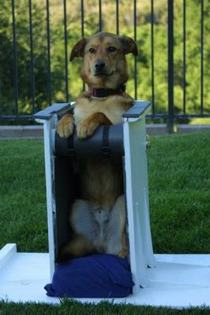

In the following pictures you will see different types of Bailey chairs and how innovative people can be to “create” their own style of feeding device. Also be aware of the different breeds that can be affected by Mega e and at various ages all the way from pups to senior canines.
Photographs used with permission.

HARRY IN HIS SWING

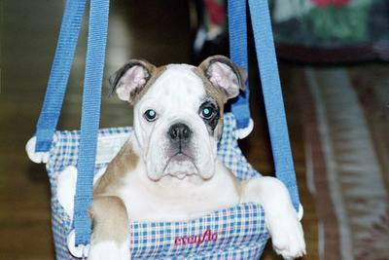
KURT BEN IRISH WOLFHOUND(GERMANY)
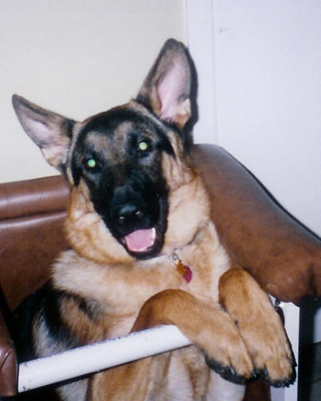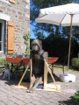

SHORTY’S COUCH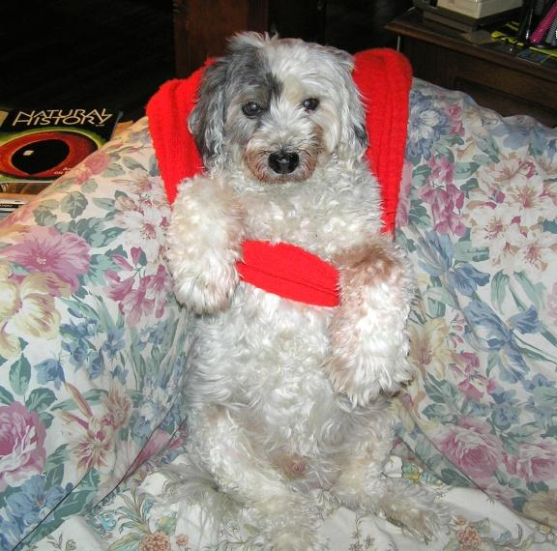

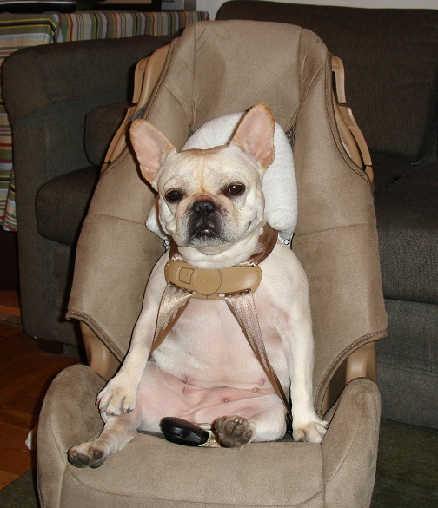

CASPER’S SWING
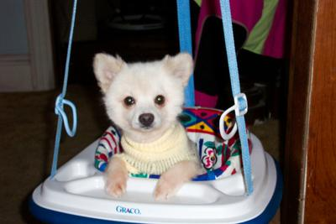

PEARL IN HER CARSEAT

CODY IN HIS DINNER JACKET

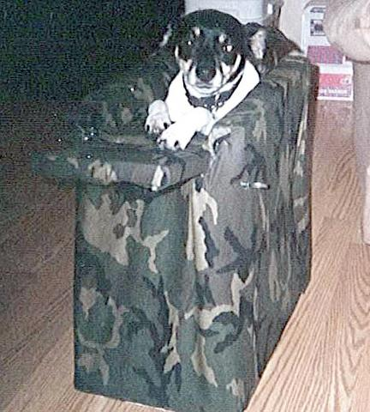

CORKIE (MEGA-E SINCE BIRTH 5 YRS OLD SEPT 2006)

LAYOUT BY LAURA DIAZ (CORKIE’S MOM)

For additional support and additional information, please feel free to join the mega esophagus group sponsored by Yahoo! at the following site:
http://groups.yahoo.com/group/megaesophagus/
Additional pictures and further information about the Bailey Chair can be found at following site:
http://www.geocities.com/bailey_chair/

BAILEY’S CHAIR (CAN BE MADE WITH A KICKPLATE AND/OR REAR ENTRY DOOR)

